**Adam Zucker**

**Power Pack**

**ECEN4013**

**Guidelines for Prototype Datasheet**

**I Provide a level 1 block diagram, schematic diagram, flowchart, data flow diagram, and/or comprehensive function list of your block.**

* Make sure that ALL arrows on your block diagram are labeled with enough information that someone reviewing your block diagrams is able to measure the signals/data/power represented by each arrow.
* Label all test point positions.
* Make sure instruments do not obscure the schematic.
* Label all inputs and outputs on the schematic with names that are consistent with the tables below.
* If giving a function list, provide the names, descriptions, inputs, and return values of each function.

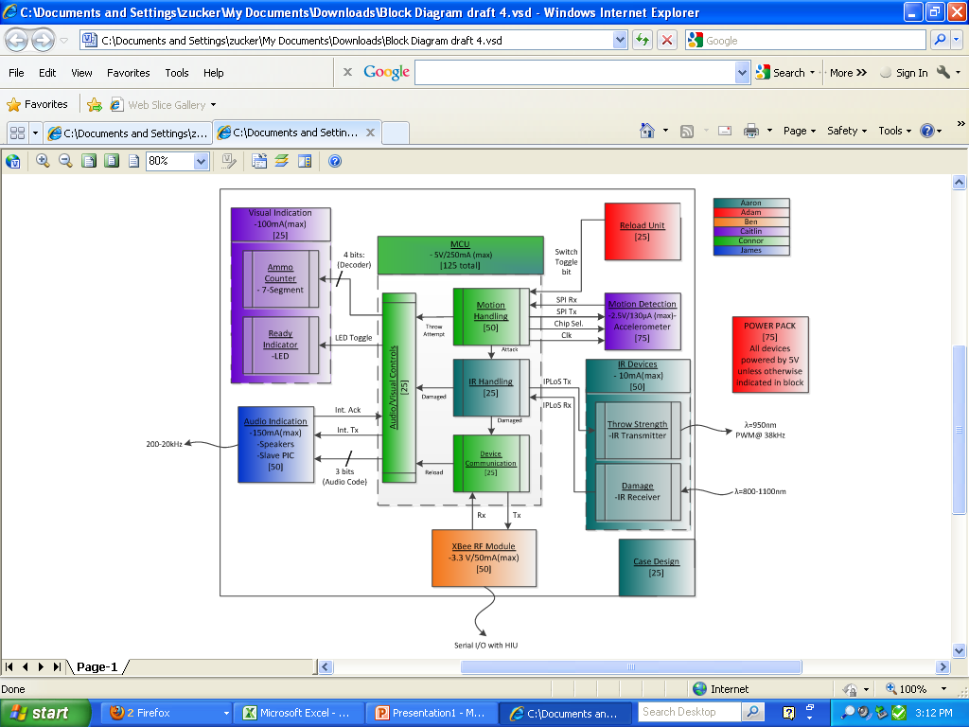

Figure 1- Team Endeavor’s Level 1 block diagram

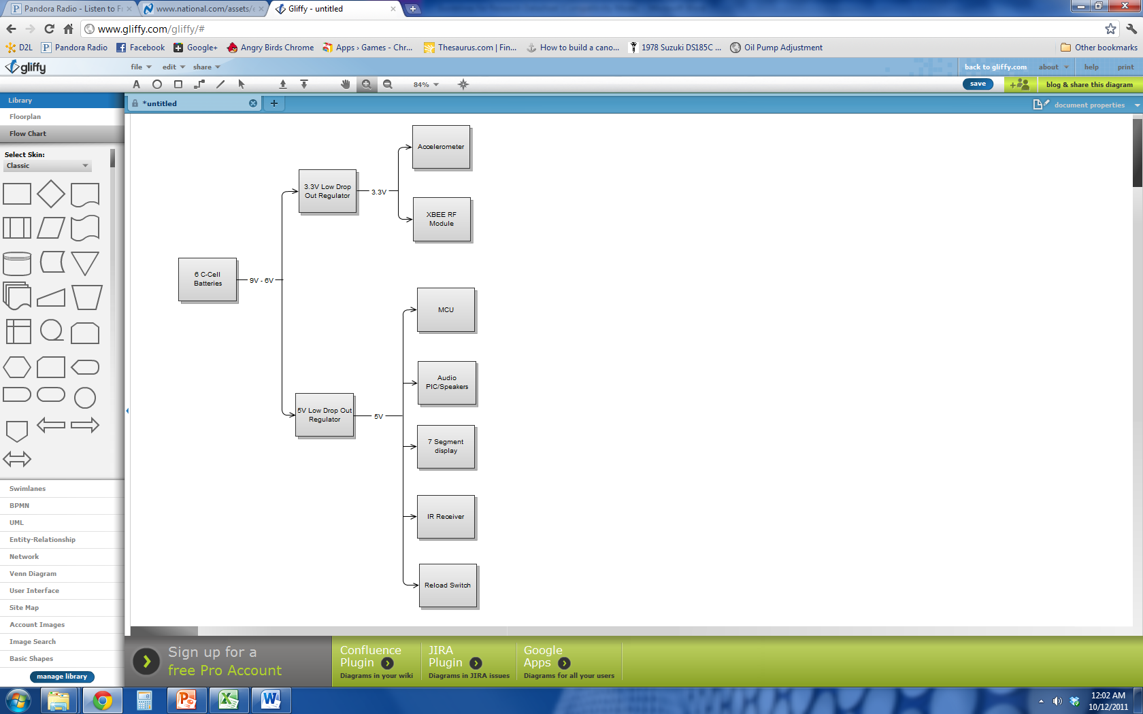

Figure 2- Level 1 block diagram of power pack

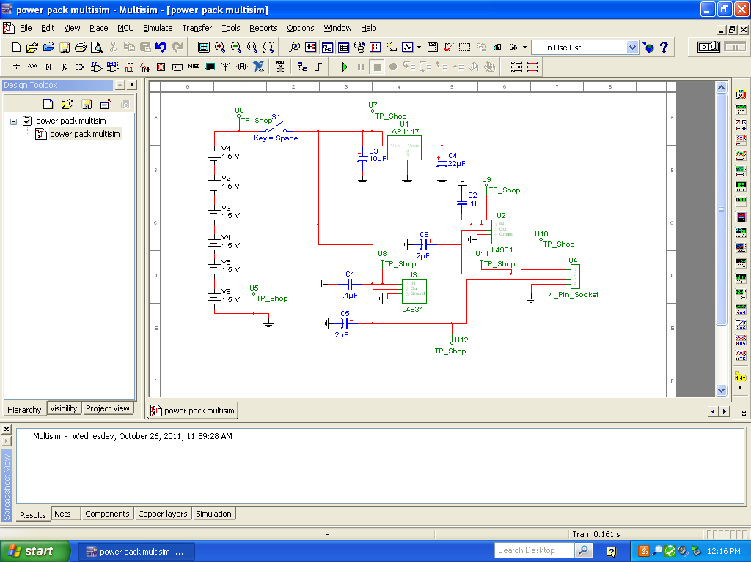

Figure 3 - Schematic of power pack

**II List all software and hardware inputs to your block.**

* State the types of signals and the expected ranges of signals entering your block.
* If you are doing code development provide test inputs used to verify functionality. Provide all function names, a description of each function, input parameters, and each function’s return value.
* You may add more lines to these tables as needed. Please expand message boxes as required for detail.

|  |  |  |
| --- | --- | --- |
| **Input Name** | **Description of Signal** | **Expected Range** |
| Input to 5V Regulator #1 (U2) | This voltage will be supplied by the battery pack | 5.9V-9V |
| Input to 5V Regulator #2 (U3) | This voltage will be supplied by the battery pack | 5.9V-9V |
| Input to 3.3V Regulator (U1) | This voltage will be supplied by the battery pack | 5.9V-9V |

**Provide graphs of time dependent signals at each input in the space below. Make sure the graph is formatted professionally and readable. If your project is code then provide a table of example input values with explanations and recorded test output.**

No time dependent signals will be used.

**III List the outputs to your block.**

* State the types of signals and the expected ranges of signals leaving your block.
* If you are doing code development please use dummy functions as test outputs. Provide all function names, a description of each function, input parameters, and each function’s return value.
* You may add more lines to these tables as needed. Please expand message boxes as required for detail.

|  |  |  |
| --- | --- | --- |
| **Output**  **Name** | **Description of Signal** | **Expected Range** |
| Output Regulated 5V #1 (U2) | This will be a regulated 5V output from U2 | 4.95V – 5.05V |
| Output Regulated 5V #2 (U3) | This will be regulated 5V output from U3 | 4.95V – 5.05V |
| Output Regulated 3.3V (U1) | This will be a regulated 3.3V output from U1 | 3.235V - 3.365V |

**Provide graphs of time dependent signals at each output in the space below. Make sure the graph is formatted professionally and readable. If your project is code then provide a table of example output values with explanations and recorded test output.**

No time dependent signals will be used.

**IV Signals at test points.**

* State the types of signals at each of the test points of your block. Provide a minimum and maximum range for these signals.
* If you are doing code development please use debug statements to test values. Provide locations and the expected values for each of these statements.
* You may add more lines to these tables as needed. Please expand message boxes as required for detail.

|  |  |  |
| --- | --- | --- |
| **T.P. Name** | **Description of Signal and measurement conditions** | **Range of Values** |
| U5 | Reference voltage | 0V |
| U6 | Battery output voltage | 5.9V-9V |
| U7 | Input to 3.3V Regulator (U1) | 5.9V-9V |
| U8 | Input to 5V Regulator #2 (U3) | 5.9V-9V |
| U9 | Input to 5V Regulator #1 (U2) | 5.9V-9V |
| U10 | Output Regulated 3.3V | 3.235V - 3.365V |
| U11 | Output Regulated 5V #1 (U2) | 4.95V – 5.05V |
| U12 | Output Regulated 5V #2 (U3) | 4.95V – 5.05V |

**Provide graphs of time dependent signals at each test point in the space below. Make sure the graph is formatted professionally and readable. If your project is code then provide a table of example internal/test values with explanations and recorded test output.**

No time dependent signals will be used.

**TA Scoring Sheet**

Student Name: ________________________________________

TA Name: ________________________________________

Due Date: _________________________________________

Date Demonstrated: _________________________________

|  |  |  |
| --- | --- | --- |
| **Points Awarded** | **What Evaluator is Looking For** | **Possible Points** |
| ######## | **I Diagrams, flowchart, and/or pseudocode** | **15** |
|  | * Level 1 Block diagram | 5 |
|  | * Inputs and outputs and testpoints clearly labeled? | 5 |
|  | * Is diagram sufficiently detailed and correct? | 5 |
| ######## | **II Inputs** | **15** |
|  | * Are all inputs from block diagram and schematic listed and are values backed up by measured data? | 10 |
|  | * Are inputs measured and graphed/tabulated? | 5 |
| ######## | **III Outputs** | **15** |
|  | * Are outputs from block diagram and schematic listed and are values backed up by measured data? | 10 |
|  | * Are outputs measured and graphed/tabulated? | 5 |
| ######## | **IV Test points** | **15** |
|  | * Are test points from block diagram and schematic listed and are values backed up by measured data? | 10 |
|  | * Are “test points” / “dummy function” graphs/ values given in a manner they can be used for system debugging? Software execution times listed? | 5 |
| ######## | **Overall: System Works** | **40** |
|  | Does the system function as it is supposed to? | 20 |
|  | Does the student have a clear path to correct/improve this block? | 10 |
|  | Is the student knowledgeable about their project? | 10 |
| **_____/100** | **Overall Evaluation** | **100** |

Comments: